1- Display the lines that contain the word “lp” in /etc/passwd file.

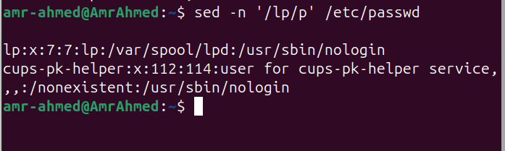

2- Display /etc/passwd file except the third line.

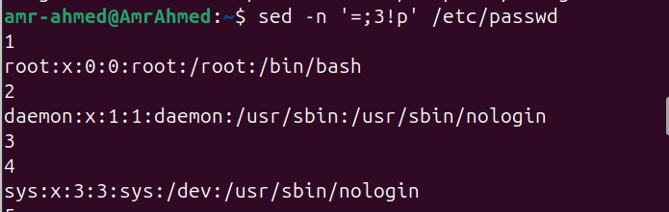

3- Display /etc/passwd file except the last line.

sed -n '=;$!p' /etc/passwd

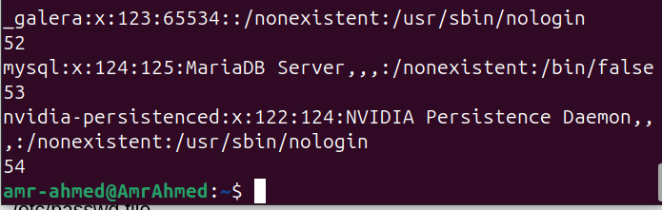

4- Display /etc/passwd file except the lines that contain the word “lp”.

sed -n '=;/lp/!p' /etc/passwd

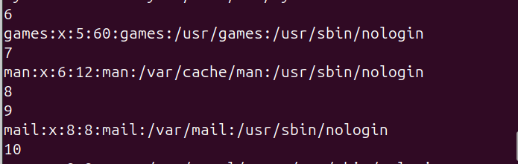

5- Substitute all the words that contain “lp” with “mylp” in /etc/passwd file.

sed –n 's/lp/mylp/gp' /etc/passwd

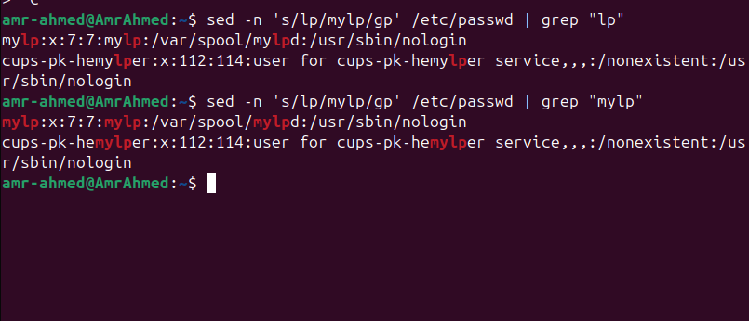

AWK

1- Print full name (comment) of all users in the system.

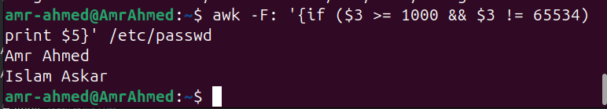  
  
2- Print login, full name (comment) and home directory of all users.( Print each line preceded

by a line number)

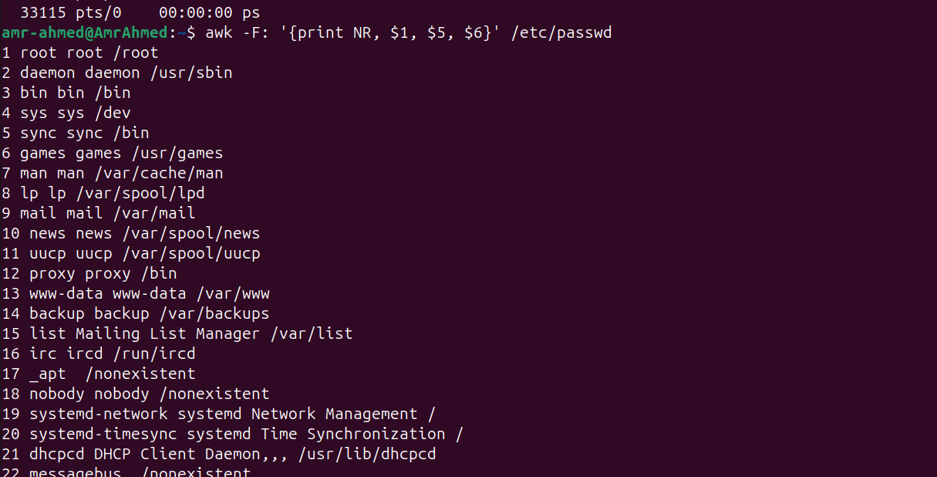

3- Print login, uid and full name (comment) of those uid is greater than 500

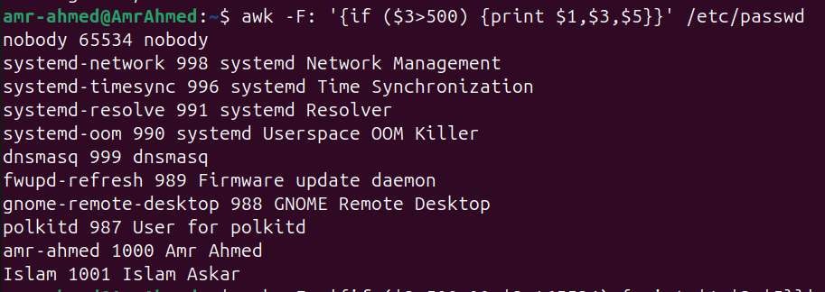

4- Print login, uid and full name (comment) of those uid is exactly 500



5- Print line from 5 to 15 from /etc/passwd

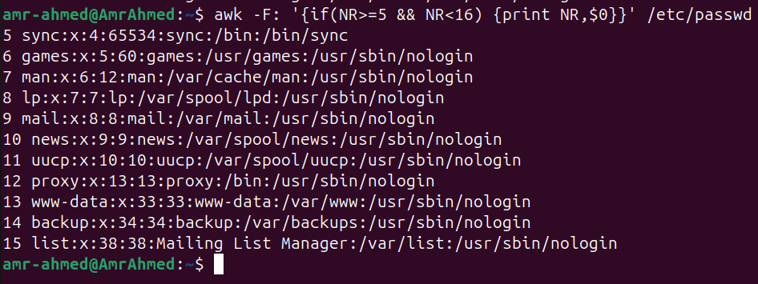

6- Change lp to mylp

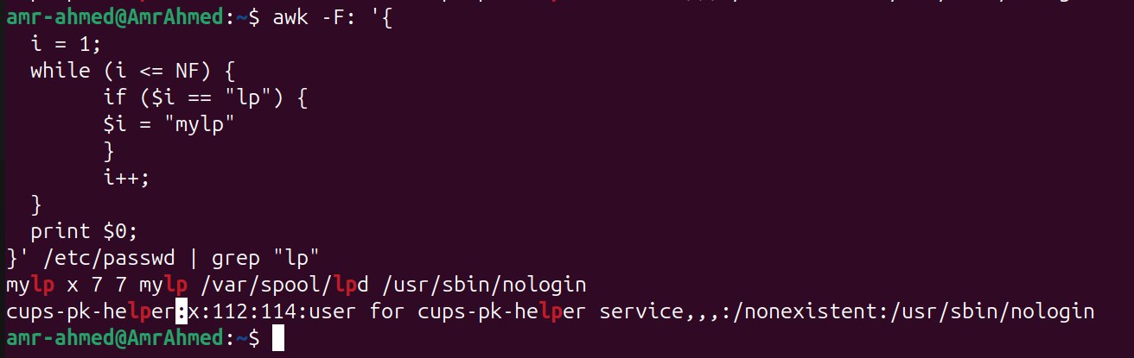

7- Print all information about greatest uid.

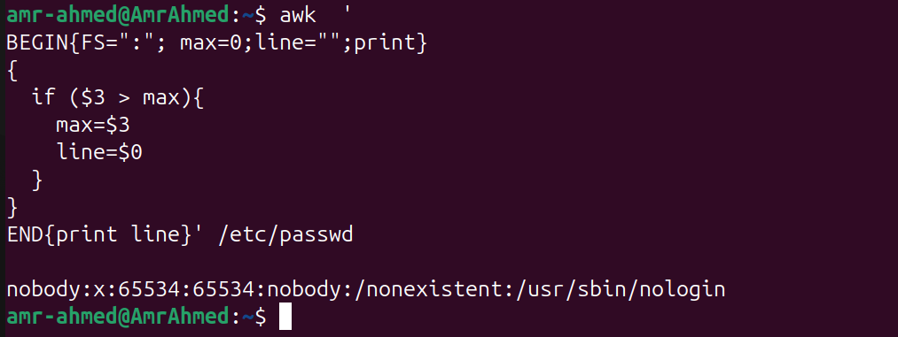

8- Get the sum of all accounts id’s.

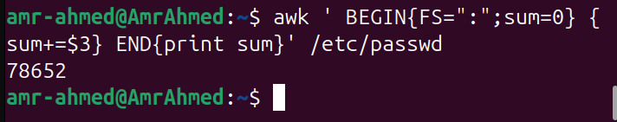

Bonus 1

awk -F: '{sum[$4] += $3} END {for (group in sum) print "GroupID " group " = " sum[group]}' /etc/passwd | sort -n -k2

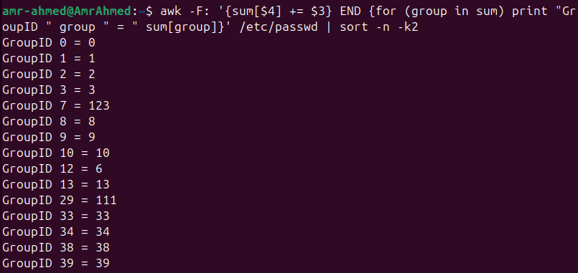

**Bonus 2**

awk -F: 'BEGIN{print "User-Group-Report"} {if(NR==1){print "Group1 Name"} else if(NR==3) {print "Group2 Name"}; print $0}' ./users

